**AMRITA VISHWA VIDYAPEETHAM**

**BANGALORE CAMPUS- 560035**



19EAC284 – Electronic circuit - II

2022-2023

**FIRE ALARM CIRCUIT USING OP-AMP PROJECT**

**NAME and REG NO.:** Priyam Joshi – BL.EN.U4EAC21053

Raja Karthikeya – BL.EN.U4EAC21054

Ramu Keerthana P – BL.EN.U4EAC21055

**DEPARTMENT:** Electronics and Computer Engineering

**SECTION:** ’I’

**SEMESTER:** IV Semester

**Fire alarm circuit using operational amplifier**

**Aim:**

To design a fire alarm circuit using operational amplifier

**Components:**

* 1 x 10 K Thermistor
* 1 x LM358 Operational Amplifier (Op – Amp)
* 1 x 4.7 KΩ Resistor (1/4 Watt)
* 1 x 10 KΩ Potentiometer
* 1 x Small Buzzer (5V Buzzer)
* Connecting Wires
* Mini Breadboard
* 5V Power Supply

**LM358 PIN Diagram:**



**Circuit:**

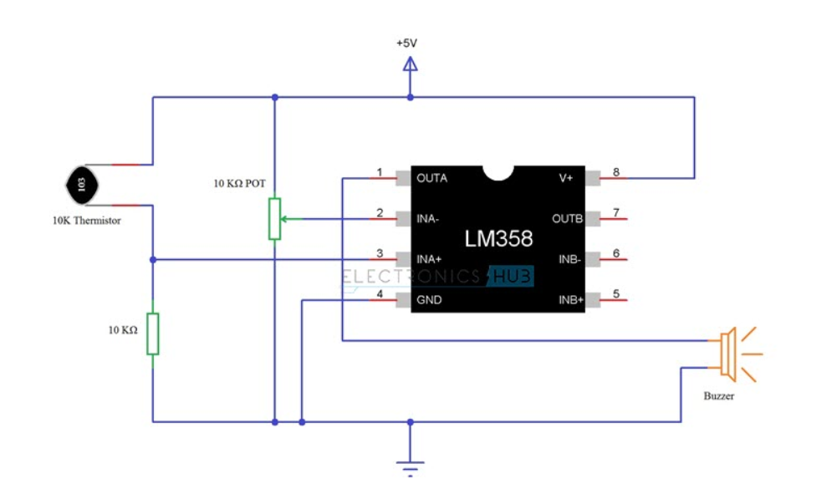

**Circuit explanation:**

The design of the Fire Alarm Circuit with Siren Sound is very simple.

First, connect the 10 KΩ Potentiometer to the inverting terminal of the LM358 Op – Amp. One end of the POT is connected to +5V, other end is connected to GND and the wiper terminal is connected to Pin 2 of Op – Amp.

We will now make a potential divider using 10 K Thermistor and 10 KΩ Resistor. The output of this potential divider i.e. the junction point is connected to the non – inverting input of the LM358 Operational Amplifier.

We have chosen a small, 5V buzzer in this project to make the alarm or siren sound. So, connect the output of the LM358 Op – amp to the 5V Buzzer directly.

Pins 8 and 4 of the LM358 IC i.e. V+ and GND are connected to +5V and GND respectively.

**Working:**

The main component in detecting the fire is the 10 K Thermistor. As we mentioned in the component description, the 10 K Thermistor used here is a NTC type Thermistor. If the temperature increases, the resistance of the Thermistor decreases.

In case of fire, the temperature increases. This increase in temperature will reduce the resistance of the 10 K Thermistor. As the resistance decreases, the output of the voltage divider will increase. Since the output of the voltage divider is given to the non – inverting input of the LM358 Op – Amp, its value will become more than that of the inverting input. As a result, the output of the Op – Amp becomes high and it activates the buzzer.

**Conclusion:**

When the temperature increases, the resistance of the Thermistor decreases. Output of the voltage divider is given to the non – inverting input of the LM358 Op – Amp, its value will become more than that of the inverting input. As a result, the output of the Op – Amp becomes high and it activates the buzzer